**Introduction**

Computer hardware interconnectedness is important in enabling them to work together efficiently. Two integral components that work in tandem to power a device are the CPU (Central Processing Unit) and the GPU (Graphics Processing Unit). These two processing units are essential for executing various task and delivering exceptional performance. Therefore, understanding the CPU and GPU is essential not only to for technology enthusiast but for anyone aiming to optimize their computing performance and understand the trend of each unit.

In the given dataset there are a total of 4,854 manufactured chips from AMD, Intel, NVIDIA, ATI and others. AMD and Intel dominate the segment with 1,662 and 1,392 chips manufactured respectively. On the other hand, NVIDIA has 1,201 chips manufactured while ATI – a less prominent vendor manufactured 535 chips while the other vendors manufactured 64 chips.

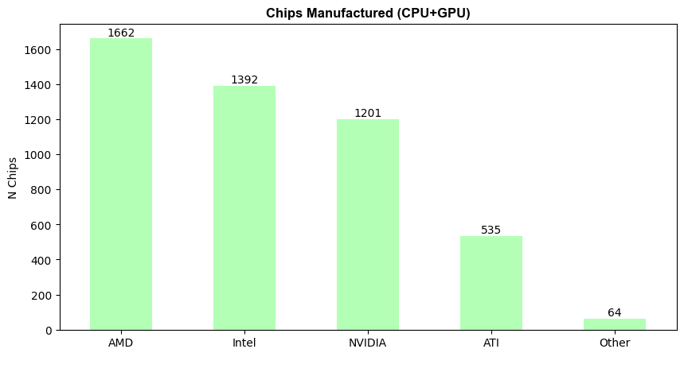

*Figure 1.* *Chips Manufactured (CPU and GPU)*

Using high performance chip means more watts that equals to better performance but also mean a higher temperature and more power consumption. When choosing a CPU or GPU cooler, TDP (Thermal Design Power) comes into play. Understanding TDP can help user to select the right cooler, ensuring optimal colling for user’s system. The TDP refers to the maximum amount of heat of a component such as CPU and GPU, generates a maximum load. This means that, it is a theoretical measure of the heat a processor will output and is often used to determine the cooling requirement for that component (DarkFlash, 2024). Additionally, higher TDP values often indicate more powerful CPUs, as they can handle more complex calculations and tasks. However, this also means they consume more power and generate more heat. Conversely, CPUs with lower TDP values are generally more energy-efficient but may not offer the same level of performance (LivewireDev, 2024).

Chips manufactured by Intel showed the lowest TDP (Thermal Design Power) on the dataset. Starting with Intel Atom Z612, Intel Atom Z600, Intel Atom Z620, Intel Atom Z500, Intel Atom Z515, Intel Atom Z610, with only 1.00 TDP and Intel Atom Z510 with only 2.00 TDP.

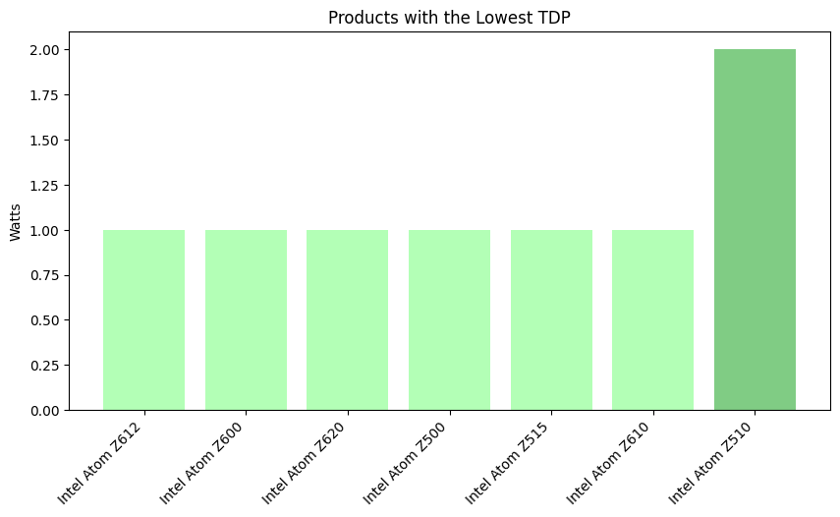

*Figure 2. Products with Lowest TDP (Thermal Design Power)*

**CPU TDP, Process Size, Die Size, Transistor and Frequency Trend**

CPU in simple terms is the brain of the computer that performs data input or output, processing, and storage function (Geeksforgeeks,2021). There are numerous CPU vendors in the market today and the includes Intel and AMD. Overall, in the given data, Intel was able to manufactured 1,242 chips while AMD was able to manufactured 950 chips.

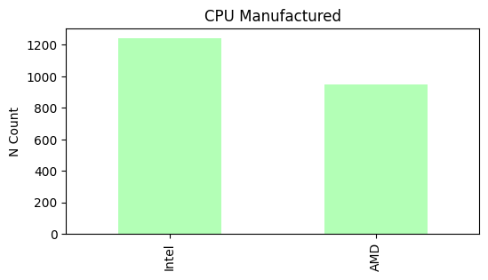

*Figure 3. CPU Manufactured by Intel and AMD*

**CPU TDP (Thermal Design Power) and its Trend**

As mentioned above, TDP is used to measure the heat of a processors output and is often used to determine the cooling requirement for that component. Between the two vendors of CPU given (Figure 3), Intel Atom line has the lowest TDP (Figure 2). This means that a low TDP signify that the device or processor is designed to consume very little power and generate minimal heat.

Throughout the years, there had been varying demand for low and high CPU processors thus affected the trend of TDP. Starting from year 2000 to 2005, it is noticeably that there is a growing demand for higher performance processors. Between 2005 to 2010, there is a decline and surge of manufactured processors, possibly reflecting the need for low performance energy as well as device that can perform demanding task. From 2010 onwards there is still fluctuation on the trend. However, it did rise sharply on 2015 and reached its peak on 2020. This rise on trend may imply that there is a demand for high performing processors due to the advancement of gaming, rendering and other task that demand more intensive power.

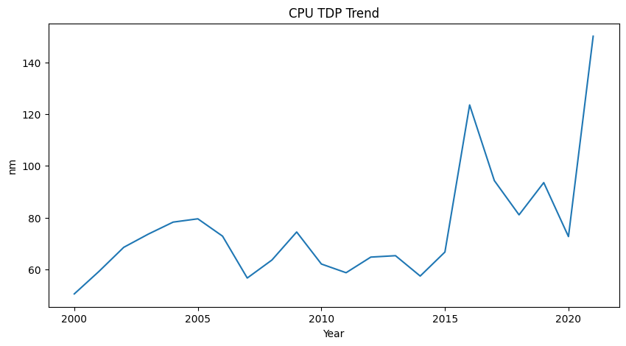

*Figure 4. CPU TDP Trend*

**CPU Process Size Trend**

A process size in simple terms refers to the physical size of the components to make up a chip. Process size is an important factor in determining its performance, efficiency and overall capability (George,2024).

Before, manufactured chips ranges from 180 nm to 75 nm over the past 6 years. With these CPU’s process size, it is a relatively older technology with may mean that is uses larger transistors thus means slower and less efficient performance. On the other hand, CPU’s process size from 2006 onwards have better performance as it gets smaller in size starting with 75nm thus results into better performance.

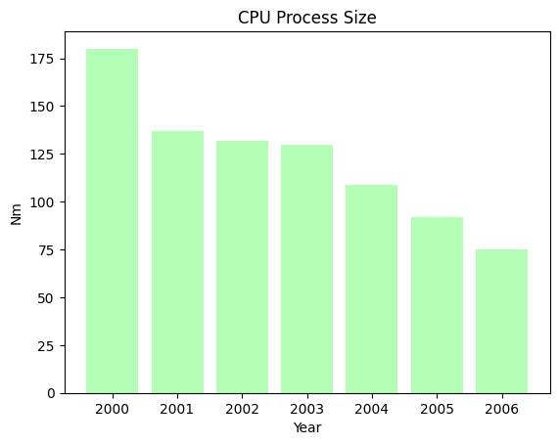

*Figure 5. CPU Process Size from Year 2000 to 2006*

CPU process size shrink in size overtime. On 2019, the first smallest process size is just 7.00 nm of AMD EPYC 7262, followed by AMD EPYC 7F32; AMD Ryzen 7 4800U; AMD Ryzen 5 4600GE; AMD Ryzen 7 4800H; AMD EPYC 7F52 on 2020 with also 7 nm and lastly, AMD EPYC 7643 with also 7 nm. Based on the given data, although CPU’s process size gets smaller, it didn’t change over the past two years.

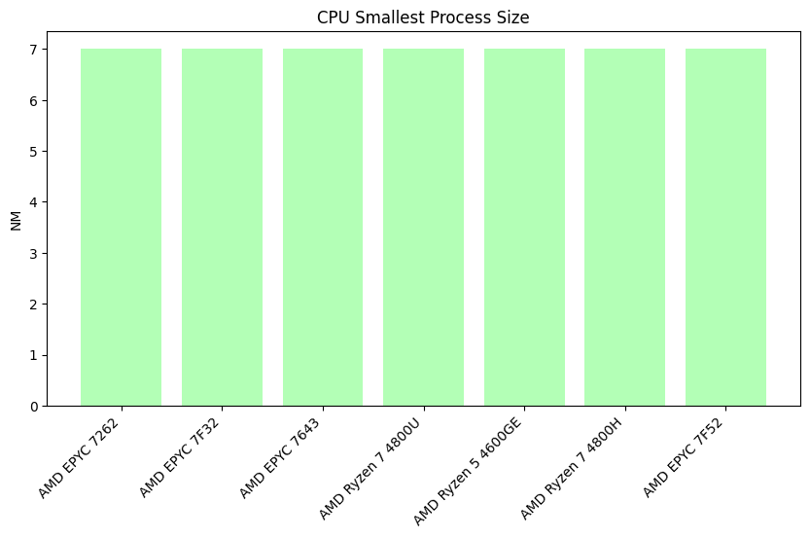

*Figure 6. CPUs Smallest Process Size from Year 2019 to 2021*

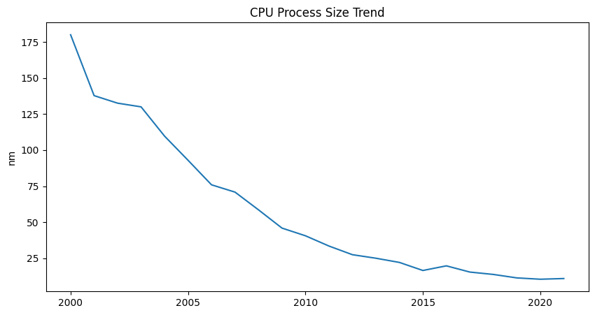The graph below shows a variation of the values. From the year 2000 with 180 nm process size down to 2019 to 2021 with only 7 nm signifies that there is an improvement of technology and achieve higher performance, power efficiency and application-wise of the device. Although there’s some rise or fluctuation on the dataset this may imply that although high performance manufactured chips are more common and needed now for this cutting -edge technology it is indeniably more expensive. On the other hand variation of process size may be preffered by some user for its affordability and its function for certain device.

*Figure 7. CPU Process Size Trend*

**CPU Die Size Trend**

In the context of processors, a die size refers to a small piece of silicion material on which the microprocessor is fabricated. It serves as the foundation for building the CPU (central processing unit) that powers the computers and other device. In addition, a die contains intricate circuitry and components necessary for the processor to perform computations and execute instructions (Lenovo, 2021).

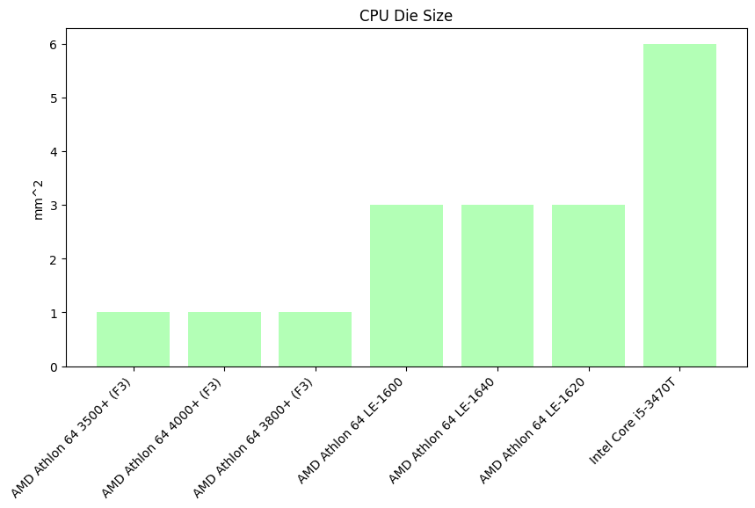 The smallest die size of a CPU based on the given dataset was from year 2007 with AMD Athlon 64 (F3) line such as 3500+,4000+,3800+ that has 1.00 mm2 which is equivalent to 65nm. In addition to these, it was followed by the AMD Athlon 64 LE line such as the -1600,-1640,and -1620 with 3.0 mm2. Lastly, is the Intel Core i5 -3470T with 6.0 mm2.

*Figure 8. CPU Die Size*

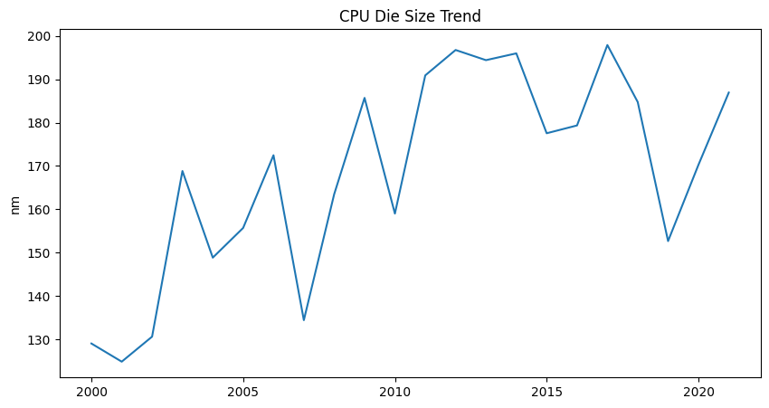The CPU die size trend shown in the line graph fluctuates significantly overtime rather than following a consistent linear decline. While there is an increase of die size between the year 2000 to 2005, there’s a decrease in certain period such as the spike between year 2005 to 2010.

*Figure 9. CPU Die Size Trend*

**CPU Transistor Trend**

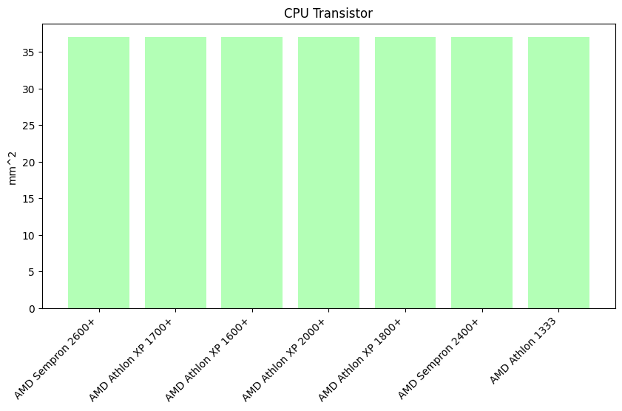 A CPUs’ transistor is a semiconductor that controls voltage or current flow in electronic signals and it amplifies and acts as a switch for them (GeeksforGeeks,2023). The given data showed that the transistor will the smallest count are as follows: AMD Sempron 2600+, AMD Athlon XP 1700+, AMD Athlon XP 1600+, AMD Athlon XP 2000+, AMD Athlon XP 1800+, AMD Sempron 2400+, and AMD Athlon 1333 with only 37 million transistor count from Year 2001 to Year 2004. This may imply that there’s a consistent linear trend during these years as the transistor count remains the same.

*Figure 10. Products with Lowest Transistor Count*

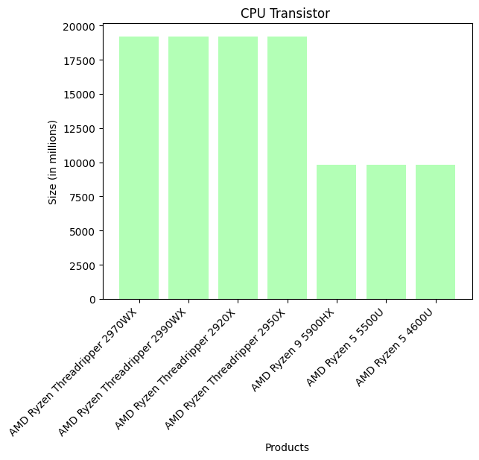 On the other hand, transistor with high count can perform more complex processes and can handle simultaneous operations which contributes to the overall performance. CPUs product with high transistor count are as follows: AMD Ryzen Threadripper 2970WX, AMD Ryzen Threadripper 2990WX, AMD Ryzen Threadripper 2920X with 19,200 transistor count and AMD Ryzen 9 5900HX; AMD Ryzen 5 5500U; AMD Ryzen 5 4600U with 9,800 transistor count.

*Figure 11. Products with Highest Transistor Count*

The table above shows products with the highest transistor count. It allows the processors to have greater performance, energy efficient, and functional. Based on the given data, this may imply that there have been a consistent rise of the transistor count overtime.

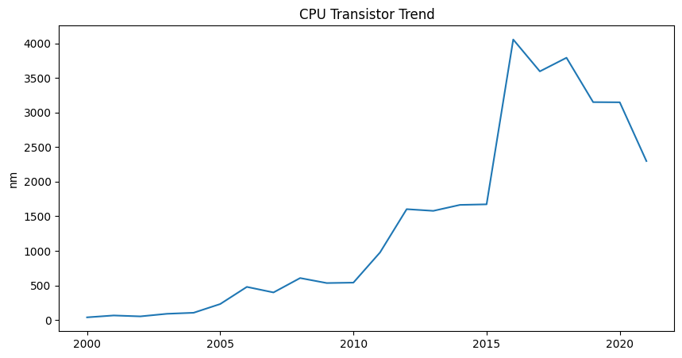

*Figure 12. CPU Transistor Trend*

Based from the line graph, this imply that there has been a rise and fluctuation on the transistor count between year 205 to 2020. This data may imply that although a high transistor count in indeed good for a better performance of a computer, however, it is also noticeable that there is a decline on transistor count and this may imply that it doesn’t guarantee better performance as adding transistor increases power consumption and heat output.

**CPU Frequency Trend**

A frequency of a CPU is also known as clock speed. It measures how fast the central processing unit can execute instructions (GeeksforGeeks, 2020). The data below shows the products that has the lowest clock speed. The following product have the lowest clock speed: Intel Atom E625C, Intel Atom E625CT, Intel Atom E620T, Intel Atom E620, AMD Athlon 600, Intel A100 which has 600.00 MHz and AMD Athlon 650 with 650 MHz clock speed.

*Figure 13. CPU Frequency Trend*

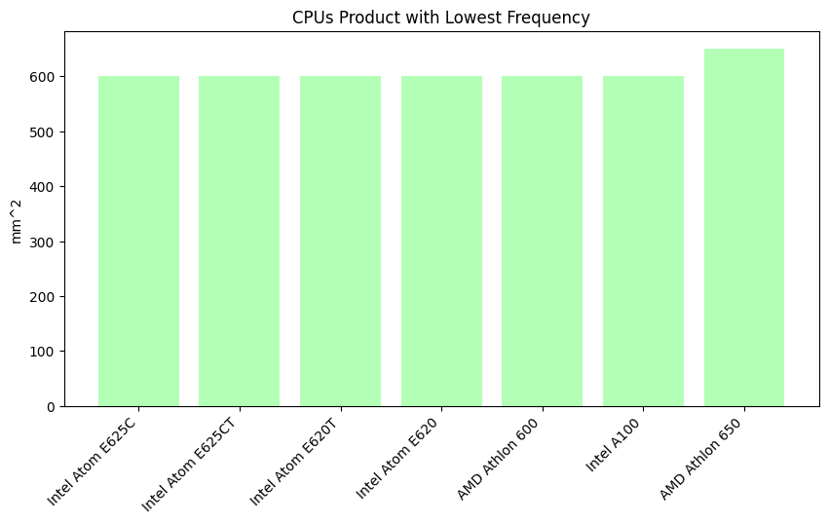

*Figure 13. Top 7 Products with Lowest Frequency*

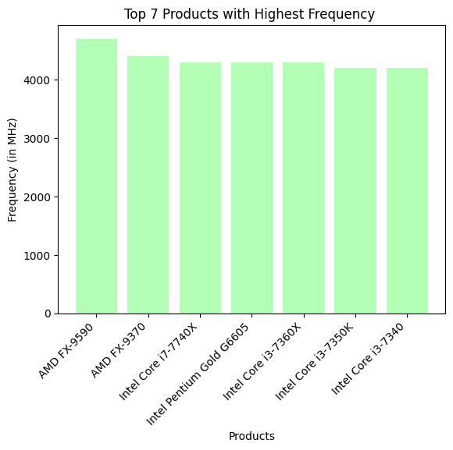On the other hand the products with highest frequency are AMD FX-9590 with 4700 MHz, AMD FX – 9370 with 4,400 MHz, Intel Core i7-7740X with 4,300 MHz, Intel Pentium Gold G6605 with 4,300 MHz , Intel Core i3 -7360X with 4,300 MHz, Intel Core i3-7350K with 4,200 MHz and lastly Intel Core i3-7340 with 4,200 MHz.

*Figure 14. Top 7 Products with Highest Frequency*

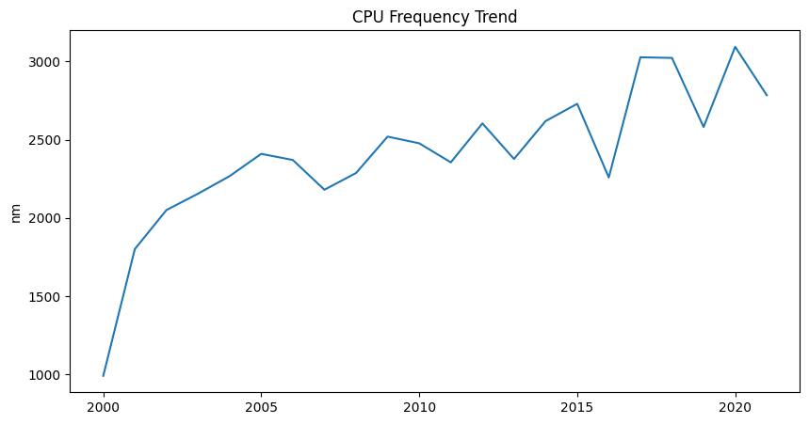The graph below shows the frequency trend of the CPU overtime. It indicates a steady increase in frequency particularly in the early 2000s and it was followed by periods of slower growth and fluctuation. From early 2000s this trend may imply that the industry was focused on boosting the computers performance by increasing the clock speed. Between the year of 2015 and 2020, the trend showed a plateau, this may imply that vendor may have faced difficulty in heat generated and power consumption thus eventually there’s a decline of trend before the year 2020.

*Figure 15. CPU Frequency Trend*

**GPU TDP, Process Size, Die Size, Transistor and Frequency Trend**

A Graphics Processing Unit (GPU) is a specialized electronic circuit in a computer that speeds up the processing of images and videos in a computer system (GeeksforGeeks,2024). There are various GPU vendors in the market today and the includes NVDIA ,AMD,ATI, Intel and other. Overall, in the given data, NVIDIA was able to manufactured 1,201 chips while AMD was able to manufactured 712 chips. Other vendor such as ATI manufactured 535 chips, Intel has 150 and other vendors on the dataset manufactured 64 GPU chips.

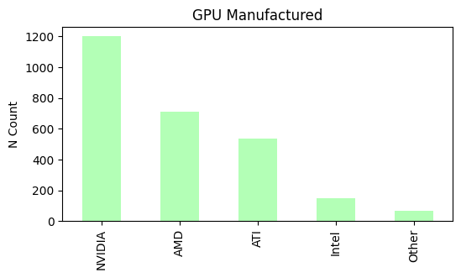

*Figure 16. GPU Manufactured*

**GPU TDP (Thermal Design Power) Trend**

As mentioned above, TDP refers to the maximum amount of energy a GPU is designed to generate under a heavy workload, which a cooling solution must dissipate. Similarly to CPUs trend, there’s a rise and fluctuation on the dataset. This may imply that throughout the year, the manufacturers may on either being power efficient or manufacture a chip that can deliver top performance.

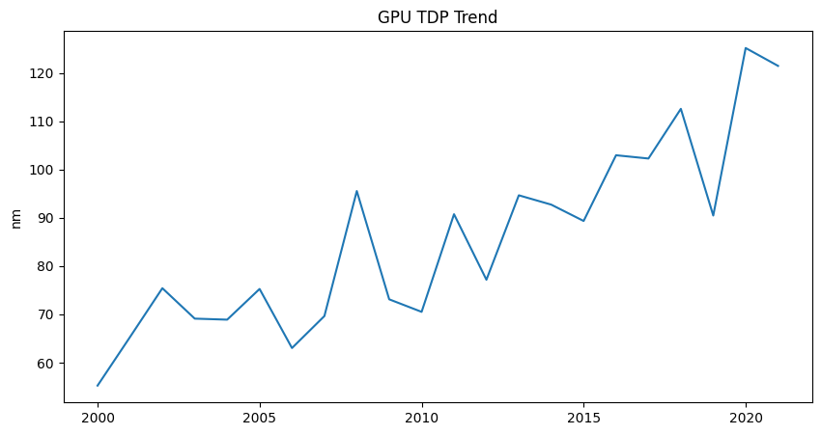

*Figure 17. GPU TDP Trend*

**GPU Process Size Trend**

A GPUs process size refers to the physical size of the components to make up a chip. Process size is an important factor in determining its performance, efficiency and overall capability (George,2024).

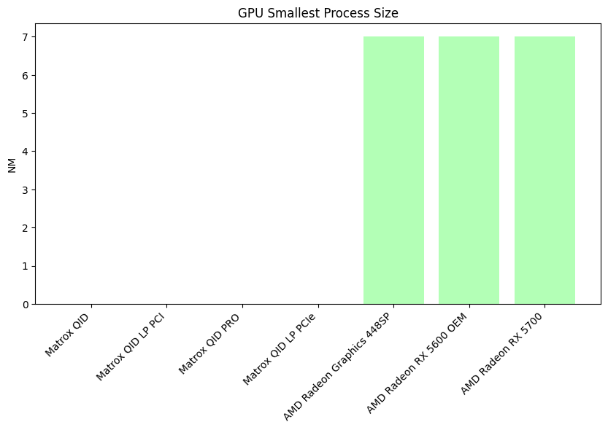

*Figure 18. GPU Process Size*

The figure above, shows the products with the smallest process size but is capable of high performance processing of images and videos. Using the dataset given, there is currently no information about Matrox manufacturer regarding its products process size. The following have only 7nm process size: AMD Radeon Graphics 448SP, AMD Radeon RX 5600 OEM, AMD Radeon RX 5700.

Similarly to the CPUs process size trend, there is a decline in the size of manufactured GPU chips. The largest manufactured GPU chip was from NVIDIA Vanta LT with 250 nm introduced in 2000. It was then followed by ATI Radeon 7000 with 180 nm that was manufactured on 2001. From then on, it is a series of decline of GPUs chip size.

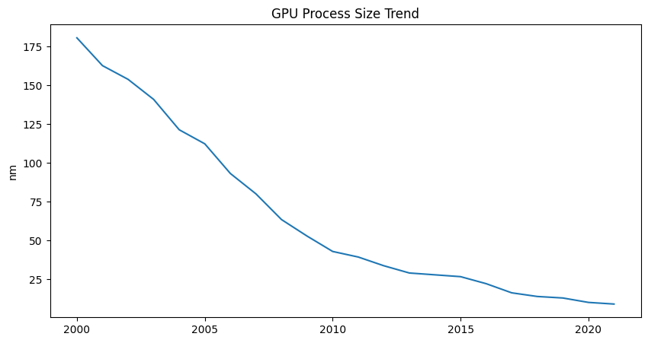

*Figure 19. GPU Process Size Trend*

The figure above shows the GPUs process size trend. It imply there has been an advancement on the GPUs chip size, smaller but powerful.

**GPU Die Size Trend**

For GPU, die size is the square inch each of silicon that the logic takes up, which (in turn) is determined by the *pitch* or how the small the logic gates are etched. In simpler terms, a die is the actual silicon chip in the graphics card that contains the transistors and circuits needed to process graphics and perform computation activities.

A smaller die size is typically more power efficient and is thermal efficient. Smaller die size is actually used on controller while larger die size enables better performance and computational capabilities. It is usually designated for a laptop, however, larger die size also means that it will consume more power and generate more heat.

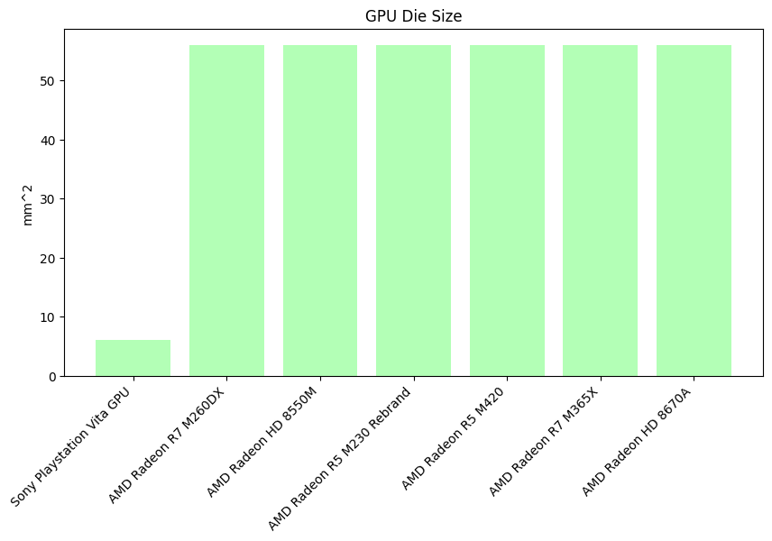

*Figure 20. GPU Die Size*

The figure above shows the products with the smallest die size. The first one is by Sony with only 6 mm2 die size followed by the AMD Radeon R7 M260DX, AMD Radeon HD 8550M, AMD Radeon R5 M230 Rebrand, AMD Radeon R5 M420, AMD Radeon R7 M365X, AMD Radeon HD 8670A with 56.00 mm2.

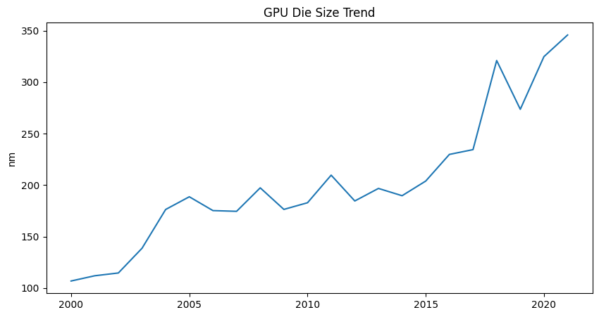

*Figure 21. GPU Die Size Trend*

The figure above shows the steady state where the size of GPU die is growing from year 2000s to recent years. However, this die size fluctuating slightly from 100 nm to 200 nm. Post 2010, there is noticeable upward trend thus this may imply that GPUs have become much more powerful and complex.

**GPU** **Transistor Trend**

Similarly to CPU, a GPUs’ transistor is a semiconductor that controls voltage or current flow in electronic signals and it amplifies and acts as a switch for them (GeeksforGeeks,2023). The transistor with lowest count is from ATI with only 8 million transistor count followed by NVIDIA Tegra 3 GPU, Matrox Millennium G550, Matrox Millennium G550 PCIe, Matrox Millennium G450, Matrox Millennium G450 LP, Matrox Millennium G450 x2 MMS with only 10 million transistor count.

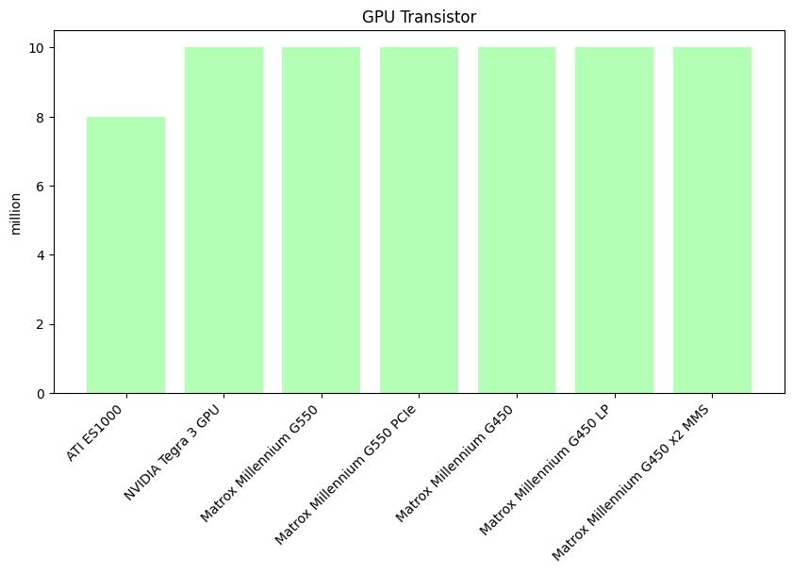

*Figure 21. GPU Transistor*

The graph below shows a variation of the values. From the year 2000 with 180 nm process size down to 2019 to 2021 with only 7 nm signifies that there is an improvement of technology and achieve higher performance, power efficiency and application-wise of the device. Although there’s some rise or fluctuation on the dataset this may imply that although high performance manufactured chips are more common and needed now for this cutting -edge technology it is indeniably more expensive. On the other hand variation of process size may be preffered by some user for its affordability and its function for certain device

**GPU Frequency Trend**

GPUs frequency refers to how fast the chip can process a video or image rendering. From the given data, the products with the lowest frequency is from Intel with only 100 MHz clock speed, followed by NVIDIA with 105 MHz, ATI with 120 MHz and lastly from Matrox with 125 MHz clock speed.

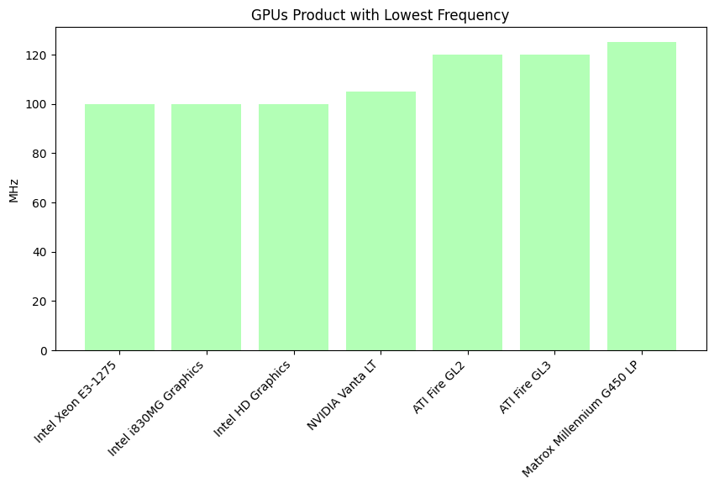

*Figure 22. GPU Products with lowest frequency*

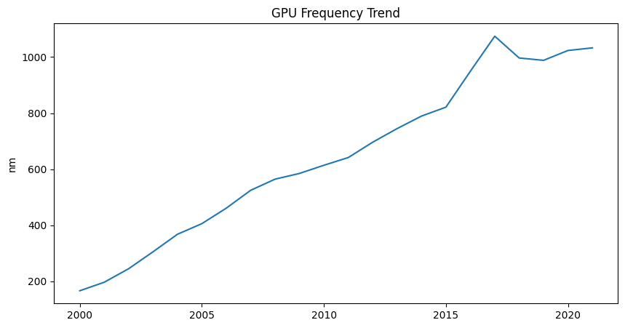 The figure above shows the products with the lowest frequency or clock speed. It is noticeable that there is an increase of clock speed such as from 100 MHz to 125 MHz.

*Figure 23. GPU Frequency Trend*

The figure above indicates that there has been a steady upward trend of frequency from 2000 to 2015 and a noticeable peak on year 2015.

**Findings**

TDP

Having a low TDP (Thermal Design Power) means that it is focus more on being power or energy efficient which is ideal for applications where the power is crucial. Additionally, it will generate very little heat or proportional to the TDP of the chip. However, there are still some drawbacks such as limited performance. A processor with low TDP can only do basic functionality such as microcontrollers.

Conversely, a high TDP is associated with powerful processors that can deliver top-tier performance. This means that the manufactured chips can do demanding task such as rendering, gaming and others. However, this also signify that there will be an increase on power consumption and significant heat generation.

Process Size

The larger the process size means that the larger the transistors used and only a few of them is used on the chip. Not only this result to slower performance but also not power efficient. Conversely, a smaller process size manufactured chip means that the transistors used are smaller which means there could be multiple transistor in one chip. This results to a higher performance and more power efficient.

Die Size

Die size trend as shown in both line graph fluctuates significantly. This may imply the accommodation for new functionality or performance need by a computer.

Transistor

A higher transistor count imply that the computer can process and achieve greater performance, is energy efficient, and functionality that can drive top-tier computing advancement. On the other hand, a low transistor count may impede its performance such as it would be only adequate for basic task one at a time.

However, having a high transistor doesn’t guarantee a better performance as it also increases the power consumption and heat generated.

Frequency

This also refers to the clock speed of the computer. The higher the frequency leads to better response in time, this means that the computer can complete more operations or instructions per seconds leading to faster execution of programs, calculations and responding to inputs more quickly.

**Recommendation**

**TDP**

When selecting a cooler, it is essential to match the cooler’s TDP rating with the thermal output of the user’s CPU. For high-TDP processors (e.g., gaming or rendering tasks), consider liquid cooling solutions or high-performance air coolers to handle the excess heat efficiently.

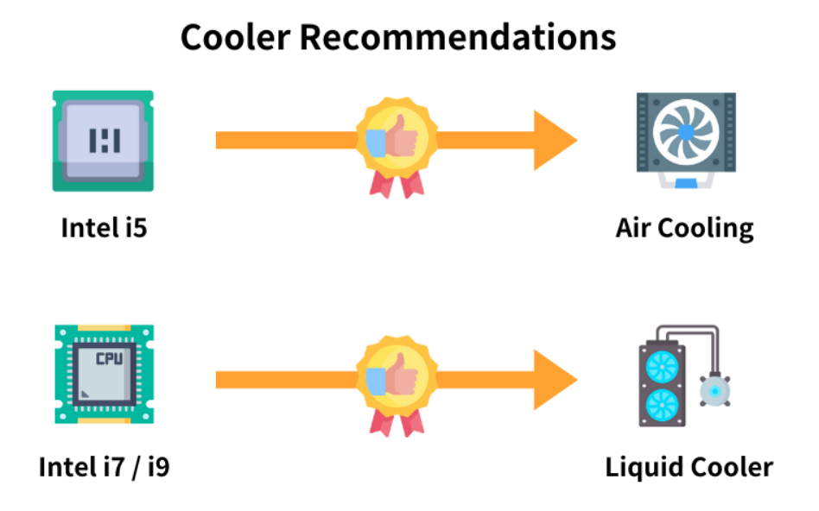

*Image from darkFlash , “What is TDP?”*

**Process Size**

When examining a process size, opt for smaller ones for better performance particularly for high-performance computing or gaming. However, larger process sizes might be more cost-efficient for simpler task or budget systems.

**Die Size**

Choose a GPUs or CPUs with smaller die size if power efficient and portability are concerned. On the other hand, manufacturers should also focus on balancing the die size of its heat management to improve efficiency without compromising it performance (refer to the fluctuation of data in both CPU and GPU).

**Transistors**

Computer or devices with high transistor could should be noted for demanding task or applications such as gaming, rendering or even high-end computing. On the other hand, manufacturers should also innovate transistors that is energy efficient.

**Frequency**

High frequency also means high clock speed which is ideal for task that requires immediate response such as gaming, or even complex calculations. However, for energy efficient consumer, a device with moderate frequency can offer decent performance with lower power consumption. Lastly, manufacturers cam also innovate or adjust the chips frequency based on the real-time needs of consumers.